Andrea Black©
2019 Workshop Series 2
Professional Development
Sexual Violence Landscape
Working with people who have experienced sexual violence?
Are you standing on the rocks or floating at sea?
What are the therapeutic interventions that work for people?
Are you responding safely?
Add to your Therapeutic Tool Kit.
This workshop is for counsellors, social workers, youth workers, volunteers, teachers and health professionals in helping roles.

Dates: 18th Nov 19 - Whangarei
25th Nov 19 - Wellsford
6th Dec 19 - Orewa
Venue confirmed on registration

Total Payment to Register now
Secure your space $100
Bank Account 02-0308-0006871-083
andreablack@xtra.co.nz
027 276 4515

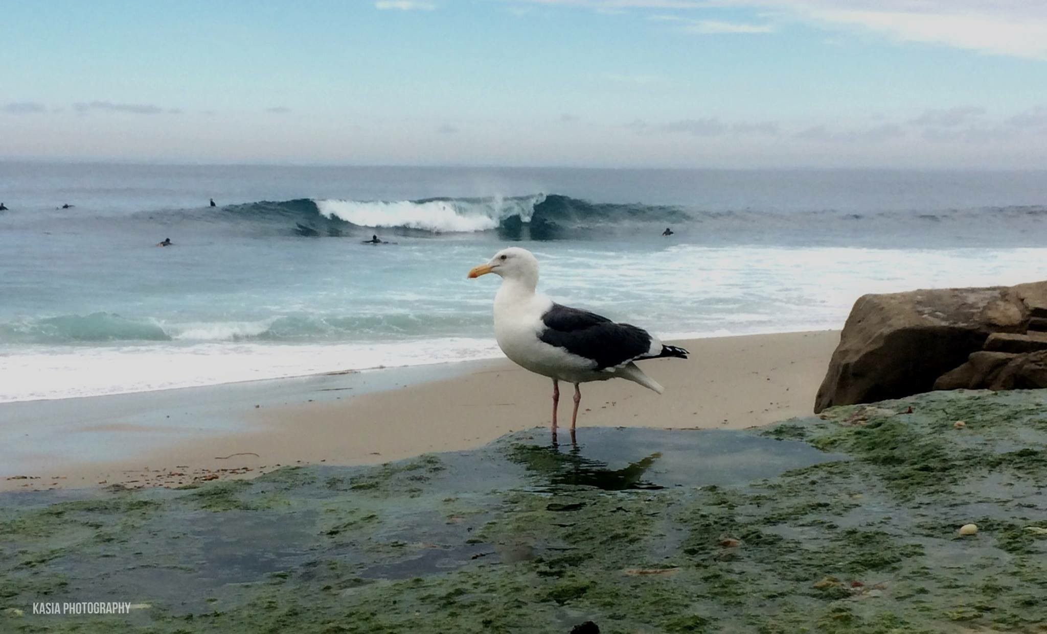Testimonial: I have worked with Andrea for 2 years. Andrea shows clear and transparent leadership while also being compassionate, empathetic, manages stressful situations with diplomacy and care. She is very aware of boundaries and utilizes them to ensure all involved are comfortable. During our working together I came to greatly admire Andrea and her strength of character, values and how she views the world. I feel privileged that I can call her a friend as well as a co-worker. Andrea always gives 100% and more in her approach and management. I have always enjoyed working with Andrea and value her wise input and suggestions.
Celia

Workshop Registration Form
Sexual Violence Landscape – Series 2
Andrea Black ©
andreablack@xtra.co.nz
027 276 4515

Please complete to secure your place.

Date you are attending:

Name of participant:
Phone contact:
Postal address:
Email:
Organisation:
Occupation/role:

Paid $100 YES NO
Bank Account
02-0308-0006871-083

Refreshments and a light lunch provided.
My dietrary requirements are:

Allergies:

Relevant information the facilitators need to know:

My purpose for attending this workshop is:

Thank you, we look forward to seeing you.

